**SENSORS ENHANCED BLIND STICK**

**A MINI PROJECT REPORT SUBMITTED IN PARTIAL FULFILLMENT OF THE REQUIREMENT FOR THE AWARD OF DERGREE OF**

**BACHELOR OF TECHNOLOGY**

**IN**

**ELECTRONICS & COMMUNICATION ENGINEERING**

**(2021-2025)**

**SUBMITTED BY**

**G. BHARATH** -**2182951021**

**P. LASYA VARDHINI -2182951040**

**Y. NAGA UDAY KIRAN -2182951066**

**D.TEJESWARA RAO -2182951014**

**UNDER THE ESTEEMED GUIDENCE OF**

**Mrs. CH. SRAVANI M. TECH (Ph. D)**

**ASSOISTANT PROFESSOR**

**DEPARTMENT OF ECE**



**DEPARTMENT OF ELECTRONICS & COMMUNICATION ENGINEERING**

**Dr. B. R. AMBEDKAR UNIVERSITY,**

**COLLEGE OF ENGINEERING**

**CERTIFICATE**

**DEPARTMENT OF ELECTRONICS &COMMUNICATION ENGINEERING**

**Dr. B. R. AMBEDKAR UNIVERSITY,**

**COLLEGE OF ENGINEERING, ETCHERLA, SRIKAKULAM.**



This is to certify that the **MINI PROJECT** work entitled **“SENSORS ENHANCED BLIND STICK”** is a Bonafide work done by **G. BHARATH (2182951021), P. LASYA VARDHINI (2182951040), Y. NAGA UDAY KIRAN (2182951066), D. TEJESWARA RAO (2182951014)** and submitted in Partial Fulfilment of the requirement for the award in degree of **BACHELOR OF TECHNOLOGY IN ELECTRONICS & COMMUNICATION ENGINEERING.**

**SIGNATURE OF THE GUIDE SIGNATURE OF THE HOD**

Mrs. CH. SRAVANI M. TECH (Ph.D.) smt. CH. SRAVANI M. TECH (Ph.D.)

ASSISTANT PROFESSOR ASSISTANT PROFESSOR

HEAD OF THE DEPARTMENT HEAD OF THE DEPARTMENT

DEPARTMENT OF ECE DEPARTMENT OF ECE

**ACKNOWLEDGEMENT**

It is Indeed with an Immense sense of Gratitude that we Acknowledge the help of our University Administration.

We are Highly Indeed for the Facilities provided to Accomplish this Mini Project.

We are Highly Indeed to our Honourable Vice-Chancellor **Prof**. **K. REMI RAJINI** Madam, Respected Registrar **Prof. P. SUJATHA** Madam, and our Principal **Prof. CH. RAJA SEKHAR RAO** Sir for the Facilities provided to Accomplish this Mini Project.

We Would like to Thank Our Head of the Department **Mrs. CH. SRAVANI** Madam for her Valuable Guidance and Constructive Criticism Throughout the Project.

We Feel Elated in Manifesting our Sense of Gratitude to our Guide **Mrs. CH. SRAVANI** mam to her Extreme Help Throughout the Project.

We are Extremely Grateful to our Faculty and Non-Teaching Staff Members for their Extreme help Throughout the Project.

Finally, we Express Our Heartful Thanks to all our Friends who help in Successfully Completion of the Project.

G. BHARATH -2182951021

P. LASYA VARDHINI -2182951040

Y. NAGA UDAY KIRAN -2182951066

D.TEJESWARA RAO -2182951014

**CONTENTS**

* **ABSTRACT**
* **INTRODUCTION**
* **LITERATURE SURVEY**
* **REQUIREMNET ANALYSIS**
* **CIRCUIT DIAGRAM**
* **WORKING MODEL**
* **CODE**
* **ADVANTAGES & DISADVANTAGES**
* **FUTURE SCOPE**
* **RESULT**
* **CONCLUSION & REFERENCES**

**ABSTRACT**

This project describes ultrasonic blind walking stick with the use of Arduino. according to who, 30 million peoples are permanently blind and 285 billion peoples with vision impairment. If you notice them, you can very well know about it they can’t walk without the help of other. One has to ask guidance to reach their destination. They have to face more struggles in their life daily life. Using this blind stick, a person can walk more confidently. This stick detects the object in front of the person and gives response to the user either by vibrating or through command. So, the person can walk without any fear. This device will be best solution to overcome their difficulties.

The main component of the project is the Ultrasonic sensor. Its principle depends on reflection of Ultrasonic sound waves. Ultrasonic sensors work by sending out a sound wave at a frequency above the range of human hearing. The transducer of the sensor acts as a microphone to receive and send the ultrasonic sound Ultrasonic sensors transmit sound waves toward a target and will determine its distance by measuring the time it took for the reflected waves to return to the receiver.

This specially designed stick which is equipped with Arduino enabled sensor facilitates the visually impaired persons to scan the obstacles in their surroundings and let them do their works independently to a great extent. In other words, it can be a perfect solution for them to fight against their disability.

**INTRODUCTION**

Visually impaired persons have difficulty to interact and feel their environment. they have little contact with surroundings. physical movement is a challenge for visually impaired persons, because it can become tricky to distinguish obstacles appearing in front of them, and they are not able to move from one place to another. they depend on their families for mobility and financial support. their mobility opposes them from interacting with people and social activities. in the past, different systems are designed with limitations without a solid understanding of the nonvisual perception.

Researchers have spent the decades to develop an intelligent and smart stick to assist and alert visually impaired persons from obstacles and give information about their location. over the last decades, research has been conducted for new devices to design a good and reliable system for visually impaired persons to detect obstacles and warn them at danger places.

Smart walking stick is specially designed to detect obstacles which may help the blind to navigate carefree. the audio messages will keep the user alert and considerably reduce accidents. this system presents a concept to provide a smart electronic aid for blind people, both in public and private space the proposed system contains the ultrasonic sensor, water sensor, buzzer, vibrating sensor and Arduino nano. the proposed system detects the obstacle images which are present in outdoor and indoor with the help of a camera. the stick measures the distance between the objects and smart walking stick by using an ultrasonic sensor. when any objects or obstacles come in range of an ultrasonic sensor and it make buzzer sound.

**LITERATURE SURVEY**

The authors Ashraf Anwar and Sultan Aljahdali in their paper used ultrasonic sensors and IR sensors for detecting the obstacle coming in the path of the blind person, also they have used heat and moisture sensor for giving more details to the person with the stick about the road or path. For alarming the blind person, they are using different buzzers and sensors that will tell the person that something is there in front of him/her. The only disadvantage of this system is that GPS is not included in this system. In the paper named ‘Implementation and Design of Smart Blind Stick for Obstacle Detection and Navigation System’ whose authors are K.S. Manikanta, T. S. S. Phani, A. Pravin used GPS/GPRS in their model which helped the visually impaired person to navigate on the roads without the help of others. As moisture sensor is not included in the model so it cannot detect water present in the path of the person using that stick. Vipul V. Nahar, Jaya L. Nikam, Poonam K. Deore in their paper used moisture sensor but excluded the GPS/GPRS module which will not help the blind person to navigate on the street but it fully helps in all other conditions which include detection of obstacle, water detection etc. The disadvantage of this system is that it will not be able to work in monsoon season as the moisture sensor will continuously keep beeping or vibrating which will irritate the person using it. This paper depicts the system which include all the sensors which are not included in the previous papers including the GPS/GPRS, which can locate the geolocation of the person using it and can inform the well-wishers of the blind person when in emergency. The authors of this paper are John Victor, Mayank Gupta, Manikandan. The model introduced by R. Dhanuja, F. Farhana, and G. Savitha is the most advanced system of blind stick till date. It includes LCD display, voice playback module and voltage regulator. The LCD display helps the person in the real world help the blind person in emergency situation such as battery drain out, some physical fault in the stick etc. The voice playback module helps the person to navigate and tell the direction by the earpiece in the blind person ears. This is surely the best advancement for the blind stick system. Voltage regulator comes in action when voltage overflow is there in the stick and prevents any damage to the stick. The disadvantage of this stick is that the location of the blind person with the stick cannot be detected as this system is not using GPS/GPRS sensors. Thinking out of the box, authors Manoj Kumar, Shekhar Singh, Mukesh Kumar thought about the irritation caused by the vibration and buzzers installed in the blind stick. So, they introduced motors which will redirect the direction of the blind stick when any obstacle comes in front of it.

**Methodology for Blind Stick Project**

The Blind Stick project aims to assist visually impaired individuals in navigating their surroundings using a combination of sensors, feedback mechanisms, and a microcontroller. The project integrates an ultrasonic sensor, Arduino Nano, vibrating motor, buzzer, and a soil moisture sensor. Below is a detailed explanation of the methodology used in the project, covering each component’s functionality and the implementation process.

1. System Design and Component Selection

The design of the Blind Stick revolves around detecting obstacles and environmental conditions, providing tactile and auditory feedback to the user. Key components include:

* Ultrasonic Sensor (e.g., HC-SR04): Measures distance to obstacles by emitting ultrasonic waves and calculating the time taken for the echo to return. This sensor is critical for obstacle detection.
* Arduino Nano: A compact and versatile microcontroller that serves as the brain of the system, processing input from sensors and controlling output devices.
* Vibrating Motor: Provides haptic feedback to alert the user about nearby obstacles.
* Buzzer: Emits sound to give an additional auditory warning.
* Soil Moisture Sensor: Detects wet or slippery surfaces to prevent potential falls.

2. Hardware Assembly

The hardware is assembled in a compact form, ensuring the device is lightweight and portable. The following steps outline the hardware setup:

1. Mounting the Ultrasonic Sensor:
   * The sensor is placed at the front of the stick to provide a clear detection path.
   * Wires from the sensor are connected to the Arduino Nano’s input pins (e.g., Trig and Echo).
2. Connecting the Vibrating Motor:
   * The motor is attached to the handle of the stick for effective haptic feedback.
   * It is connected to the Arduino via a transistor circuit to control the motor’s activation.
3. Installing the Buzzer:
   * The buzzer is placed near the user’s hand or ear for audible alerts.
   * It is wired to one of the Arduino’s digital output pins.
4. Integrating the Soil Moisture Sensor:
   * This sensor is embedded at the base of the stick to detect moisture on the ground.
   * Wires are connected to the Arduino’s analog input pins for signal processing.
5. Power Supply:
   * A portable battery pack is used to power the Arduino and other components.
   * The power supply is secured within the stick to avoid adding bulk.

3. Software Development

The Arduino Nano is programmed using the Arduino IDE. The software development process includes the following steps:

1. Initialization:
   * Set up input and output pins for all components.
   * Define the threshold distances for the ultrasonic sensor and the moisture level for the soil moisture sensor.
2. Ultrasonic Sensor Functionality:
   * Emit ultrasonic pulses from the Trig pin.
   * Measure the time taken for the echo to return using the Echo pin.
   * Calculate the distance using the formula:
   * Compare the calculated distance with predefined thresholds to determine obstacle proximity.
3. Haptic and Auditory Feedback:
   * If an obstacle is detected within a certain range, activate the vibrating motor and/or buzzer.
   * Use pulse-width modulation (PWM) to control the intensity of the vibration based on the obstacle’s distance.
   * Generate distinct sound patterns with the buzzer for varying distances.
4. Soil Moisture Sensor Integration:
   * Read the analog signal from the moisture sensor.
   * If the moisture level exceeds the threshold, trigger a unique alert using the buzzer or vibration motor.
5. Optimization:
   * Implement debouncing for sensor readings to avoid false triggers.
   * Use power-saving modes to extend battery life.

4. Testing and Calibration

Each component is individually tested and calibrated to ensure optimal performance:

* Ultrasonic Sensor Calibration:
  + Measure distances with known values and adjust the code to match.
  + Test in different environments to account for variations in sound propagation.
* Vibrating Motor and Buzzer:
  + Test feedback intensity and patterns to ensure they are noticeable without being overwhelming.
  + Ensure synchronization between obstacle detection and feedback activation.
* Soil Moisture Sensor:
  + Test the sensor on various surfaces to determine accurate thresholds for wetness.

5. Integration and Field Testing

After successful individual testing, the system is integrated and tested as a whole:

1. Lab Testing:
   * Simulate different scenarios, such as varying obstacle distances and wet surfaces.
   * Adjust thresholds and feedback mechanisms based on user feedback.
2. Field Testing:
   * Allow visually impaired individuals to use the device in real-world settings.
   * Record observations and user feedback to identify areas for improvement.

6. Safety and User Comfort

The Blindstick is designed with safety and user comfort in mind:

* Ensure that feedback mechanisms do not cause discomfort.
* Use lightweight and durable materials for the stick.
* Add a protective casing for electronics to prevent damage.

7. Final Implementation

The final product integrates all features seamlessly, ensuring:

* Accurate obstacle detection and timely feedback.
* Reliable performance in various environmental conditions.
* Ease of use and portability for the target users.

8. Future Enhancements

To improve the Blindstick further, consider the following enhancements:

* GPS and Navigation Support: Add a GPS module for location tracking and navigation assistance.
* Bluetooth Connectivity: Enable pairing with smartphones for advanced features like route planning.
* AI Integration: Use machine learning to classify obstacles and provide context-aware feedback.
* Solar Charging: Incorporate solar panels for sustainable energy.

By following this comprehensive methodology, the Blindstick project can effectively serve as a reliable aid for visually impaired individuals, enhancing their independence and mobility in everyday life.

**REQUIREMENT ANALYSIS**

**HARDWARE COMPONENTS:**

* ARDUINO NANO x 1
* ULTRA SONIC SENSOR x 1
* USB CABLE (for Arduino)
* FEW CONNECTING JUMPING WIRES
* A LAPTOP WITH INTERNET CONNECTION

**ARDUINO NANO:**

After Arduino UNO, the most popular board in the Arduino line-up is probably the Arduino Nano. Both UNO and Nano are based on ATmega328P Microcontroller but Nano is significantly smaller in size compared to UNO. Despite the size, Arduino Nano packs in more or less the same features as UNO. If you compare UNO and Nano, then Nano lacks the DC Power Jack and contains a mini-B type USB connector. Other than that Nano is very similar to UNO in terms of functionality. The Nano board is designed in such a way that the pins are breadboard friendly so that you can easily mount it on one for your DIY projects.

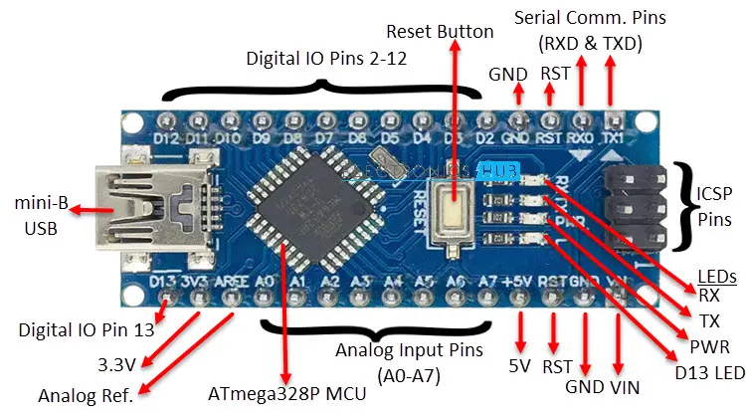

|  |  |
| --- | --- |
| **MCU** | ATmega328P |
| **Architecture** | AVR |
| **Operating Voltage** | 5V |
| **Input Voltage** | 7V – 12V |
| **Clock Speed** | 16 MHz |
| **Flash Memory** | 32 KB (2 KB of this used by bootloader) |
| **SRAM** | 2 KB |
| **EEPROM** | 1 KB |
| **Digital IO Pins** | 22 (of which 6 can produce PWM) |
| **Analog Input Pins** | 8 |

**ULTRASONIC SENSOR:**

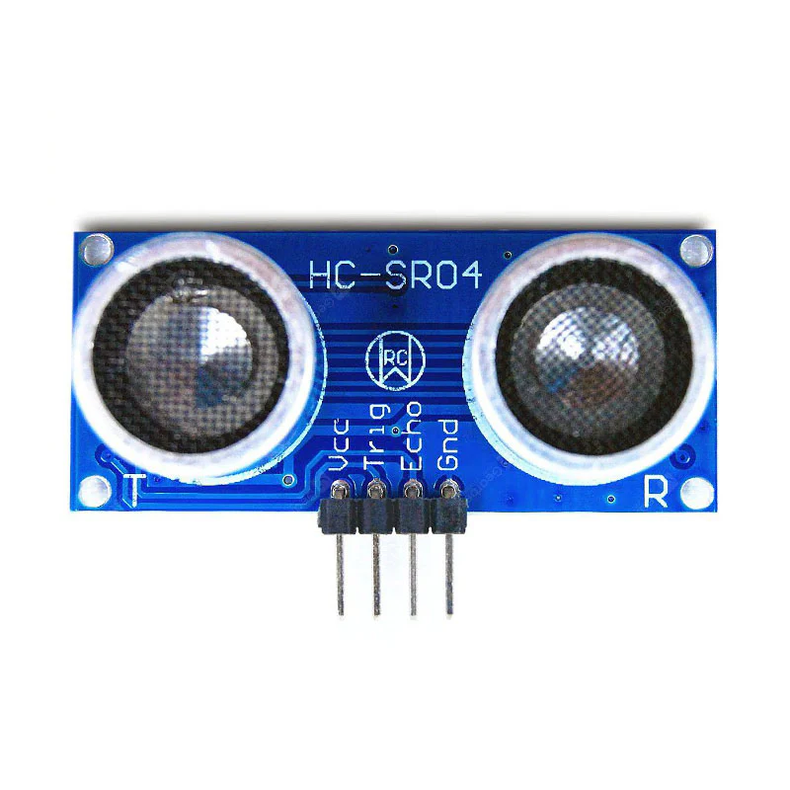

ULTRASONIC SENSOR Ultrasonic detection is most commonly used in industrial applications to detect hidden tracks, discontinuities in metals, composites, plastics, ceramics, and for water level detection. For this purpose, the laws of physics which are indicating the propagation of sound waves through solid materials have been used since ultrasonic sensors using sound instead of light for detection.

**Operation of ultrasonic sensors:** When an electrical pulse of high voltage is applied to the ultrasonic transducer it vibrates across a specific spectrum of frequencies and generates a burst of sound waves. Whenever any obstacle comes ahead of the ultrasonic sensor the sound waves will reflect back in the form of echo and generates an electric pulse. It calculates the time taken between sending sound waves and receiving the echo. The echo patterns will be compared with the patterns of sound waves to determine the detected signal’s condition.

**Applications involving Ultrasonic detection**: The distance of obstacle or discontinuities in metals is related to the velocity of sound waves in a medium through which waves are passed and the time taken for echo reception. Hence the ultrasonic detection can be used for finding the distances between particles, for detecting the discontinuities in metals and for indicating the liquid level.

**Ultrasonic Distance Measurement:** Ultrasonic sensors are used for distance measuring applications. These gadgets regularly transmit a short burst of ultrasonic sound to a target, which reflects the sound back to the sensor. The system then measures the time for the echo to return to the sensor and computes the distance to the target using the speed of sound within the medium.

Different sorts of transducers are utilized within industrially accessible ultrasonic cleaning devices. An ultrasonic transducer is affixed to a stainless-steel pan which is filled with a solvent and a square wave is applied to it, conferring vibration energy on the liquid.

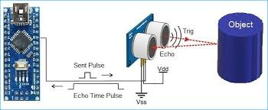

**Ultrasonic Distance Sensor** The ultrasonic distance sensors measure distance using sonar; an ultrasonic (well above human hearing) beat is transmitted from the unit and distance-to-target is determined by measuring the time required for the echo return. The output from the ultrasonic sensor is a variable-width beat that compares to the distance to the target. **Ultrasonic Obstacle Detection** Ultrasonic sensors are used to detect the presence of targets and to measure the distance to targets in many robotized processing plants and process plants. Sensors with an ON or OFF digital output are available for detecting the presence of objects and sensors with an Analog output which changes relative to the sensor to target separation distance are commercially available.

Ultrasonic obstacle sensor consists of a set of ultrasonic receiver and transmitter which operate at the same frequency. The point when something moves in the zone secured the circuit’s fine offset is aggravated and the buzzer/alarm is triggered.

**CONNECTIONS:**

* ULTRA-SONIC Sensor **VCC** is Connected to Arduino **+5v.**
* **TRIG** Pin is Connected to **D9** pin on Arduino nano.
* **ECHO** Pin is Connected to **D10** pin on Arduino nano.
* **GND** pin is Connected to **GND** Pin on Arduino nano.

**JUMPER WIRES:**

This is Male to Female Jumper Wires (20cm) - 40 Pieces pack. A very Flexible and easily detachable cable to the no. of wires according to your requirement. It has 1Pin male to the 1pin female header with both ends. Also, it is compatible with 2.54 mm mil spacing pin headers. This cable is an electrical wire or group of them in a cable with a connector or pins at each end, which is normally for interconnecting the components of a bread board or other prototype or test circuit, internally or with other equipment or components, without soldering. Individual Dupont Cables are fitted by inserting their end connectors into the slots provided in a breadboard, the header connector of a circuit board, or a piece of test equipment.

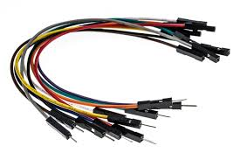

**BUZZER:**

Buzzer a small buzzer is a common feature in electronic products and can provide an effective way of interacting with users or raising an alarm. depending on the type and strength of the signals available to drive the buzzer, the physical space available, and the required audio sound pressure level (spl), a magnetic or piezoelectric type will be the most common options for your application. one also has the choice between an indicator or transducer design.

Indicators have built-in drive circuitry and are easy to design-in but can produce only a single, continuous tone or pulsed output. on the other hand, transducers can produce more complex sounds but need you to provide an excitation waveform and external components for switching and amplification. this cui insights blog guides you through “buzzer basics”, including the different types of buzzers, their features, and associated design challenges, to help you choose the most suitable type for your applications.

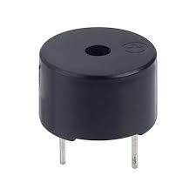

**CONNECTIONS:**

* + Positive terminal of the buzzer to **Pin D11** on Arduino nano.
  + Negative terminal of the buzzer to **GND** on Arduino nano.

**USB CABLE:**

Cable wire This is a standard a-b USB cable. it can be used to connect your computer to Arduino that use a full-sized b-type USB connection, such as the uno and mega2560.

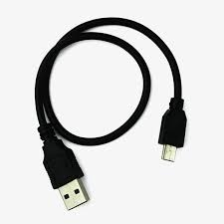

**SOIL MOISTURE SENSOR:**

Soil moisture sensors typically refer to sensors that estimate volumetric water content. Another class of sensors measure another property of moisture in soils called water potential.

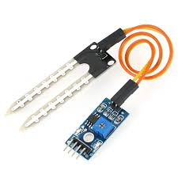

**CONNECTIONS:**

* Soil-Moisture Sensor **VCC** is connected to **5v** on Arduino nano.
* **GND** Pin is Connected to **GND** Pin on Arduino nano.
* **A0** Pin is Connected to **A0** Pin on Arduino nano.

**9V BATTERY:**

Use a 9v battery with your Arduino projects to provide a higher-current power supply for things like motors. you can also feed 9v power into your Arduino dc barrel jack using 9v battery clip with a jack to get a regulated 5v from the internal regulator.

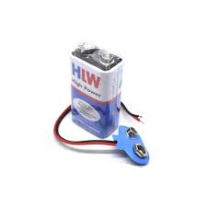

**CONNECTIONS:**

* Positive Terminal is Connected to **Vin** Pin on Arduino nano.
* Negative Terminal is Connected to **GND** Pin on Arduino nano.

**VIBRATOR MOTOR:**

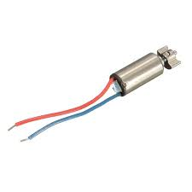Vibration motor is a DC motor in a compact size that is used to inform the users by vibrating on receiving signals.

**CONNECTIONS:**

* Positive Terminal is Connected to **D8** Pin on Arduino nano.
* Negative Terminal is Connected to **GND** Pin on Arduino nano.

**SOFTWARW REQUIREMENT:**

You will need the **Arduino IDE** to write and upload code to the Arduino Nano. The Arduino Integrated Development Environment - or Arduino Software (IDE) - contains a text editor for writing code, a message area, a text console, a toolbar with buttons for common functions and a series of menus. It connects to the Arduino hardware to upload programs and communicate with them.

Programs written using Arduino Software (IDE) are called **sketches**. These sketches are written in the text editor and are saved with the file extension. ino. The editor has features for cutting/pasting and for searching/replacing text. The message area gives feedback while saving and exporting and also displays errors. The console displays text output by the Arduino Software (IDE), including complete error messages and other information. The bottom righthand corner of the window displays the configured board and serial port. The toolbar buttons allow you to verify and upload programs, create, open, and save sketches, and open the serial monitor.

IDE VERIFY File

*Verify* Checks your code for errors compiling it.

IDE UPLOAD File

*Upload* Compiles your code and uploads it to the configured board. See [**uploading**](https://docs.arduino.cc/software/ide-v1/tutorials/arduino-ide-v1-basics/#uploading) below for details.

Note: If you are using an external programmer with your board, you can hold down the "shift" key on your computer when using this icon. The text will change to "Upload using Programmer"

IDE NEW File

*New* Creates a new sketch.

IDE OPEN File

*Open* Presents a menu of all the sketches in your sketchbook. Clicking one will open it within the current window overwriting its content.

Note: due to a bug in Java, this menu doesn't scroll; if you need to open a sketch late in the list, use the **File | Sketchbook** menu instead.

IDE SAVE File

*Save* Saves your sketch.

IDE SERMON File

*Serial Monitor* Opens the [**serial monitor**](https://docs.arduino.cc/software/ide-v1/tutorials/arduino-ide-v1-basics/#serial-monitor).

Additional commands are found within the five menus: **File**, **Edit**, **Sketch**, **Tools**, **Help**. The menus are context sensitive, which means only those items relevant to the work currently being carried out are available.

**File**

* *New* Creates a new instance of the editor, with the bare minimum structure of a sketch already in place.
* *Open* Allows to load a sketch file browsing through the computer drives and folders.
* *Open Recent* Provides a short list of the most recent sketches, ready to be opened.
* *Sketchbook* Shows the current sketches within the sketchbook folder structure; clicking on any name opens the corresponding sketch in a new editor instance.
* *Examples* Any example provided by the Arduino Software (IDE) or library shows up in this menu item. All the examples are structured in a tree that allows easy access by topic or library.
* *Close* Closes the instance of the Arduino Software from which it is clicked.
* *Save* Saves the sketch with the current name. If the file hasn't been named before, a name will be provided in a "Save as." window.
* *Save as...* Allows to save the current sketch with a different name.
* *Page Setup* It shows the Page Setup window for printing.
* *Print* Sends the current sketch to the printer according to the settings defined in Page Setup.
* *Preferences* Opens the Preferences window where some settings of the IDE may be customized, as the language of the IDE interface.
* *Quit* Closes all IDE windows. The same sketches open when Quit was chosen will be automatically reopened the next time you start the IDE.

**Edit**

* *Undo/Redo* Goes back of one or more steps you did while editing; when you go back, you may go forward with Redo.
* *Cut* Removes the selected text from the editor and places it into the clipboard.
* *Copy* Duplicates the selected text in the editor and places it into the clipboard.
* *Copy for Forum* Copies the code of your sketch to the clipboard in a form suitable for posting to the forum, complete with syntax colouring.
* *Copy as HTML* Copies the code of your sketch to the clipboard as HTML, suitable for embedding in web pages.
* *Paste* Puts the contents of the clipboard at the cursor position, in the editor.
* *Select All* Selects and highlights the whole content of the editor.
* *Comment/Uncomment* Puts or removes the // comment marker at the beginning of each selected line.
* *Increase/Decrease Indent* Adds or subtracts a space at the beginning of each selected line, moving the text one space on the right or eliminating a space at the beginning.
* *Find* Opens the Find and Replace window where you can specify text to search inside the current sketch according to several options.
* *Find Next* Highlights the next occurrence - if any - of the string specified as the search item in the Find window, relative to the cursor position.
* *Find Previous* Highlights the previous occurrence - if any - of the string specified as the search item in the Find window relative to the cursor position.

**Sketch**

* *Verify/Compile* Checks your sketch for errors compiling it; it will report memory usage for code and variables in the console area.
* *Upload* Compiles and loads the binary file onto the configured board through the configured Port.
* *Upload Using Programmer* This will overwrite the bootloader on the board; you will need to use Tools > Burn Bootloader to restore it and be able to Upload to USB serial port again. However, it allows you to use the full capacity of the Flash memory for your sketch. Please note that this command will NOT burn the fuses. To do so a *Tools -> Burn Bootloader* command must be executed.
* *Export Compiled Binary* Saves a .hex file that may be kept as archive or sent to the board using other tools.
* *Show Sketch Folder* Opens the current sketch folder.
* *Include Library* Adds a library to your sketch by inserting #include statements at the start of your code. For more details, see [**libraries**](https://docs.arduino.cc/software/ide-v1/tutorials/arduino-ide-v1-basics/#libraries) below. Additionally, from this menu item you can access the Library Manager and import new libraries from .zip files.
* *Add File...* Adds a supplemental file to the sketch (it will be copied from its current location). The file is saved to the data.

 subfolder of the sketch, which is intended for assets such as documentation. The contents of the data folder are not compiled, so they do not become part of the sketch program.

**Tools**

* *Auto Format* This formats your code nicely: i.e. indents it so that opening and closing curly braces line up, and that the statements inside curly braces are indented more.
* *Archive Sketch* Archives a copy of the current sketch in .zip format. The archive is placed in the same directory as the sketch.
* *Fix Encoding & Reload* Fixes possible discrepancies between the editor char map encoding and other operating systems char maps.
* *Serial Monitor* Opens the serial monitor window and initiates the exchange of data with any connected board on the currently selected Port. This usually resets the board, if the board supports Reset over serial port opening.
* *Board* Select the board that you're using. See below for [**descriptions of the various boards**](https://docs.arduino.cc/software/ide-v1/tutorials/arduino-ide-v1-basics/#boards).
* *Port* This menu contains all the serial devices (real or virtual) on your machine. It should automatically refresh every time you open the top-level tools menu.
* *Programmer* For selecting a hardware programmer when programming a board or chip and not using the onboard USB-serial connection. Normally you won't need this, but if you're [**burning a bootloader**](https://docs.arduino.cc/built-in-examples/arduino-isp/ArduinoISP) to a new microcontroller, you will use this.
* 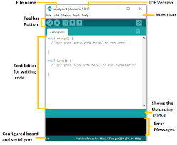*Burn Bootloader* The items in this menu allow you to burn a [**bootloader**](https://docs.arduino.cc/hacking/software/Bootloader) onto the microcontroller on an Arduino board. This is not required for normal use of an Arduino board but is useful if you purchase a new AT mega microcontroller (which normally come without a bootloader). Ensure that you've selected the correct board from the **Boards** menu before burning the bootloader on the target board. This command also set the right fuses.

**BLOCK DIAGRAM:**

**POWER SUPPLY**

**ARDIUNO NANO**

**BUZZER**

**ULTRA SONIC SENSOR**

**VIBRATOR MOTOR**

**SOIL MOISTURE**

**SENSOR**

**WORKING MODEL:**

The Sensors Enhanced Blind Stick operates on the integration of an Arduino Nano microcontroller, ultrasonic sensor, soil moisture sensor, buzzer, mini rotor vibration motor, and a 9V battery. It uses the ultrasonic sensor to detect obstacles in the user's path by emitting ultrasonic waves and measuring the time taken for the echo to return and calculating the distance to the obstacle. When powered on using the 9V battery, the Arduino Nano initializes all connected components and sensors. The ultrasonic sensor continuously emits ultrasonic waves. If an obstacle is within the pre-defined range (e.g., 6 0 cm), the sensor calculates the distance by measuring the time taken for the echo to return and actuates the buzzer to sound and the vibration motor to offer tactile feedback. At the same time, it monitors the soil for wet surfaces or slippery areas with the soil moisture sensor. The Arduino will emit a different form of alert to the buzzer and vibration motor when high levels of moisture are detected. Powered by a 9V battery, the system continues to scan the environment around the user in real time and feedback for better safety and navigation.

**CIRCUIT DIAGRAM:**

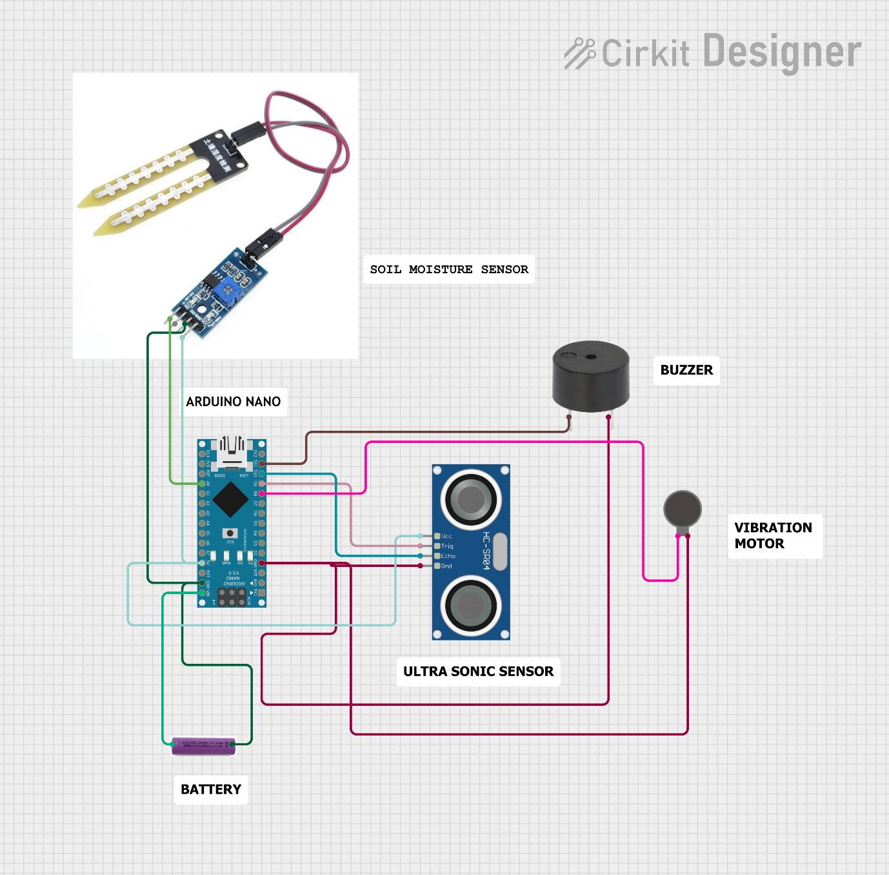

**CODE:**

const int trigPin = 9; // Trigger Pin of Ultrasonic Sensor

const int echoPin = 8; // Echo Pin of Ultrasonic Sensor

const int motorPin = 10;

const int motorPin1 = 11;

void setup () {

Serial.begin(9600); // Starting Serial Terminal

pinMode (trigPin, OUTPUT);

pinMode (motorPin, OUTPUT);

pinMode (motorPin1, OUTPUT);

pinMode (echoPin, INPUT);

digitalWrite (motorPin, LOW);

digitalWrite (motorPin1, LOW);

}

void loop ()

{

long duration, inches, cm;

digitalWrite (trigPin, LOW);

delayMicroseconds (2);

digital Write (trig Pin, HIGH);

delay Microseconds (10);

digital Write (trig Pin, LOW);

duration = pulse in (echo Pin, HIGH);

cm = microsecondsToCentimeters(duration);

Serial.print(cm);

Serial.print("cm");

Serial.println();

delay (100);

if (cm > 0 && cm <= 7)

{

Serial.println("TAP ON");

digital Write (motor Pin, HIGH);

digital Write (motorPin1, HIGH);

}

else if (cm > 7)

{

Serial.println("TAP OFF");

digital Write (motor Pin, LOW);

digital Write (motorPin1, LOW);

}

delay (9000);

}

long microsecondsToInches (long microseconds) {

return microseconds / 74 / 2;

}

long microsecondsToCentimeters (long microseconds) {

return microseconds / 29 / 2;

}

**ADVANTAGES:**

* **Increased Accessibility and Independence**
  + Ultrasonic sensors detect obstacles, enabling users to navigate safely by sensing distances and identifying potential hazards.
  + The buzzer and vibrator motor provide tactile and auditory feedback, making it easier for the visually impaired to respond to obstacles.
* **Compact and Lightweight**
  + Using an Arduino Nano makes the device compact, lightweight, and easy to carry.
* **Customizable Alerts**
  + The buzzer and vibrator motor offer flexibility for alert customization, allowing users to set preferences based on their comfort level.
* **Low Cost**
  + The components (ultrasonic sensor, soil moisture sensor, Arduino Nano, etc.) are relatively inexpensive, making the device affordable for a wide range of users.
* **Low Power Consumption**
  + The Arduino Nano and associated components consume less power, increasing battery life and operational duration.
* **Easy Maintenance and Upgradability**
  + The modular design allows for easy replacement or upgrading of individual components without needing to overhaul the entire system.

**DISADVANTAGES:**

* **Limited Range of Ultrasonic Sensors**
  + Ultrasonic sensors may have a limited detection range and may not detect very distant obstacles effectively.
* **Interference Issues**
  + External factors such as noise or reflective surfaces may interfere with ultrasonic sensor readings, causing false positives or missed detections.
* **Complexity for Users**
  + The combination of auditory (buzzer) and tactile (vibrator motor) alerts may be overwhelming for some users, especially without prior training.
* **Environmental Limitations**
  + Soil moisture sensors might not work effectively on all surfaces (e.g., concrete or dry areas) and may give misleading alerts in certain environments.
* **Battery Dependence**
  + The device relies on a battery, requiring regular charging or replacement, which can be inconvenient for users.
* **Limited Processing Power**
  + The Arduino Nano has limited computational power, which could restrict the addition of advanced features like machine learning-based obstacle detection.

**FUTURE SCOPE:**

* **Integration with GPS and Navigation Systems:** Incorporating GPS modules to guide users through predefined routes and provide real-time navigation assistance. Using voice-based navigation systems for added accessibility.
* **Enhanced Obstacle Detection:** Upgrading ultrasonic sensors with LiDAR or IR sensors to detect obstacles more accurately, even in complex environments. Adding object recognition capabilities using machine learning to differentiate between types of obstacles (e.g., vehicles, pedestrians).
* **Environmental Monitoring:** Expanding the soil moisture sensor’s functionality to include detecting terrain types, ice, or oil spills for comprehensive ground awareness. Incorporating additional sensors like temperature or humidity sensors for real-time weather condition alerts.
* **Wireless Connectivity and IoT Integration:** Adding Bluetooth or Wi-Fi modules to connect with smartphones or other devices for remote monitoring or advanced features. Integrating with IoT platforms to gather and analyse user data for performance optimization.
* **Energy Efficiency Enhancements:** Incorporating solar panels or advanced battery technologies to reduce the need for frequent charging and extend operational hours.
* **AI-Based Features:** Implementing AI for predictive analytics, such as warning users about upcoming obstacles based on previous patterns. Voice-assisted AI to provide users with verbal cues about the surroundings.
* **Multi-Language and Inclusive Alerts:** Adding multilingual support for audio alerts to make the device usable for a global audience. Ensuring the system is adaptive for people with additional disabilities, such as hearing impairment.
* **Emergency Alert System:** Incorporating SOS functionality to alert family members or emergency services in case of distress or accidents.

**CONCLUSION:**

The smart walking stick, constructed with at most accuracy, will help the blind people to move from one place to another without others help. this could also be considered a crude way of giving the blind a sense of vision. this stick reduces the dependency of visually impaired people on other family members. The proposed combination of various working units makes real-time system that monitors Position of the user and provides dual. the smart stick detects objects or obstacles in front of users and feeds warning back, in the form of voice making rather than vibration also the incorporation of automatic room equipment switching in the stick will be useful while they are indoor. the advantage of the system lies in the fact that it can prove to be a low-cost solution to millions of blind people worldwide.

**REFERENCE:**

* World Health Organization, “Visual Impairment and Blindness,” Fact sheet N “282”, Oct 2014. ​
* National Disability Policy: A Progress Report – October 2014, National Council on Disability, Oct 2014.​
* T. Terlau and W. M. Penrod, "KSonar Curriculum Handbook", Available from: <http://www.aph.org/manuals/ksonar.pdf>, June 2008.​
* L. Whitney, "Smart cane to help blind navigate", Available from: "http://news.cnet.com/8301-17938\_105-10302499-1.html", 2009.​
* J.M. Hans du Buf, J. Barroso, JoJo M.F. Rodrigues, H.Paredes, M. Farra jota, H. Fernandes, J. Jos, V. Teixeira, M. Saleiro.”The Smart Vision Navigation Prototype for Blind Users”. International Journal of Digital Content Technology and its Applications, Vol.5 No .5, pp. 351 – 361, May 2011.​
* I. Ulrich, and J. Bornstein, “The guide cane-Applying mobile robot technologies to assist the visually impaired,” IEEE Transaction on Systems, Man, and Cybernetics-Part A: Systems and Humans, vol. 31, no. 2, pp. 131-136, 2001.​
* P. Meijer, “An Experimental System for Auditory Image Representations,” IEEE Transactions on Biomedical Engineering, vol.39, no 2, pp. 112-121, Feb 1992. ​